1.
#include <iostream>
#include <vector>
using namespace std;

void searchSubsets(vector<int>& nums, int targetSum, int idx, vector<int>& temp, vector<vector<int>>& output) {
if (targetSum == 0) {
output.push_back(temp);
return;
}

for (int i = idx; i < nums.size(); i++) {
if (nums[i] > targetSum) continue;

temp.push_back(nums[i]);
searchSubsets(nums, targetSum - nums[i], i + 1, temp, output);
temp.pop_back();
}
}

int main() {
vector<int> nums = {2, 3, 5, 7};
int targetSum = 10;
vector<vector<int>> output;
vector<int> tempSubset;

searchSubsets(nums, targetSum, 0, tempSubset, output);

cout << "Subsets that sum to " << targetSum << " are:\n";
for (const auto& subset : output) {
for (int num : subset) {
cout << num << " ";
}
cout << endl;
}

return 0;
}

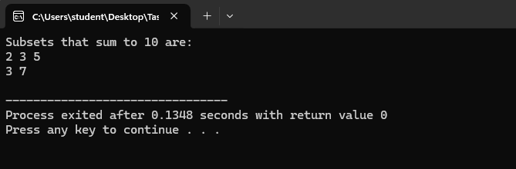
2.
#include<iostream>
#include<vector>

using namespace std;

class Solution {
public:
bool exist(vector<vector<char>>& board, string word) {
for(int r = 0; r < board.size(); r++) {
for(int c = 0; c < board[0].size(); c++) {
if(dfs(board, word, 0, r, c)) return true;
}
}
return false;
}

bool dfs(vector<vector<char>>& board, string word, int index, int row, int col) {
if(index == word.size()){
return true;
}

if(row < 0 || row >= board.size() || col < 0 || col >= board[0].size() || board[row][col] == '0' || board[row][col] != word[index] ){
return false;
}

char s = board[row][col];
board[row][col] = '0';
bool found = dfs(board,word,index+1,row+1,col) || dfs(board,word,index+1,row,col+1) || dfs(board,word,index+1,row-1,col) || dfs(board,word,index+1,row,col-1);
board[row][col] = s;
return found;

}
};

int main() {
Solution sol;

vector<vector<char>> board = {
{'A','B','C','E'},
{'S','F','C','S'},
{'A','D','E','E'}
};

string word1 = "ABCCED";
string word2 = "SEE";
string word3 = "ABCB";

cout << "Word " << word1 << " exists? " << (sol.exist(board, word1) ? "Yes" : "No") << endl;
cout << "Word " << word2 << " exists? " << (sol.exist(board, word2) ? "Yes" : "No") << endl;
cout << "Word " << word3 << " exists? " << (sol.exist(board, word3) ? "Yes" : "No") << endl;

return 0;
}
